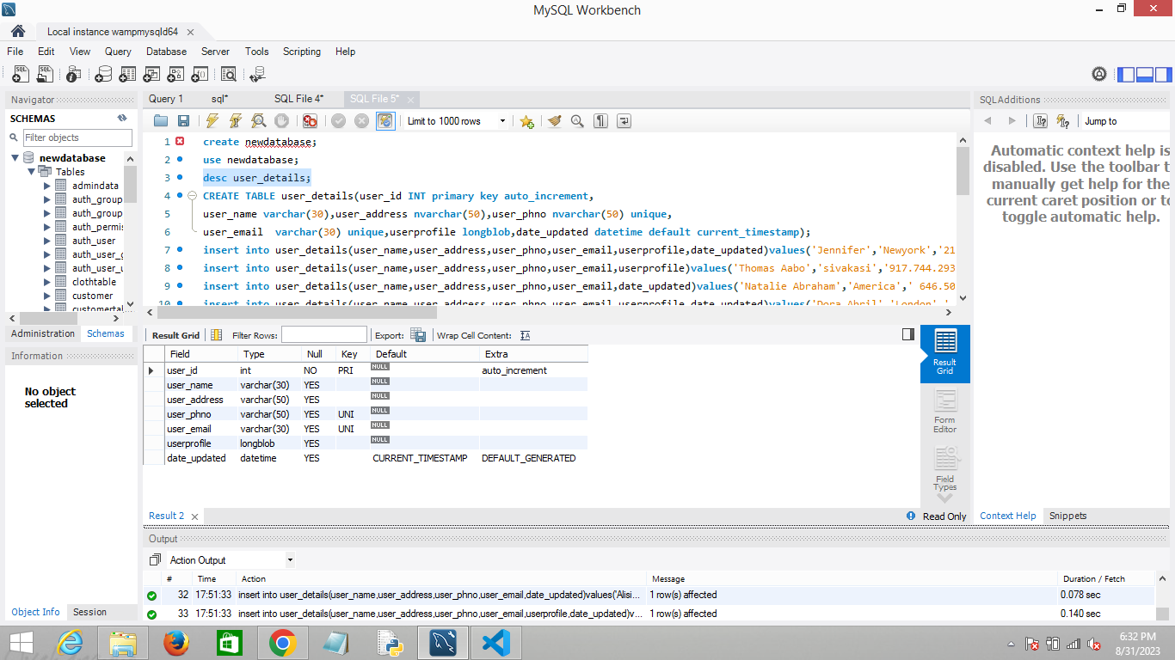

Blob type which will accept both binary image from local folder and as a online image link

While inserting images into table, MYSQL have privileges on their own directory ('C:/ProgramData/MySQL/MySQL Server 8.0/Uploads/’) by default.

EXAMPLE:

load_file('C:/ProgramData/MySQL/MySQL Server 8.0/Uploads/image1.jpg')

**SQL QUERIES**

Create database newdatabase;

use newdatabase;

CREATE TABLE user_details(user_id INT primary key auto_increment,

user_name varchar(30),user_address nvarchar(50),user_phno nvarchar(50) unique,

user_email varchar(30) unique,userprofile longblob,date_updated datetime default current_timestamp);

insert into user_details(user_name,user_address,user_phno,user_email,userprofile,date_updated)values('Jennifer','Newyork','212.909.8464','jennifer.man@elliman.com',load_file('C:/ProgramData/MySQL/MySQL Server 8.0/Uploads/image1.jpg'),'2023-8-12');

insert into user_details(user_name,user_address,user_phno,user_email,userprofile)values('Thomas Aabo','sivakasi','917.744.2937','thomas.aabo@elliman.com',load_file('C:/ProgramData/MySQL/MySQL Server 8.0/Uploads/image2.jpg'));

insert into user_details(user_name,user_address,user_phno,user_email,date_updated)values('Natalie Abraham','America',' 646.505.2249,310.402.1891','natalie.abraham@elliman.com','2023-8-12');

insert into user_details(user_name,user_address,user_phno,user_email,userprofile,date_updated)values('Dora Abril','London',' 212.891.7667, 347.677.2986','dabril@elliman.com',load_file('C:/ProgramData/MySQL/MySQL Server 8.0/Uploads/image6.jpg'),'2023-8-12');

insert into user_details(user_name,user_address,user_phno,user_email,userprofile,date_updated)values('Phillip Acha','France','212.965.6006, 646.678.6203','phillip.acha@elliman.com',load_file('C:/ProgramData/MySQL/MySQL Server 8.0/Uploads/image5.jpg'),'2023-8-20');

insert into user_details(user_name,user_address,user_phno,user_email,userprofile,date_updated)values('Brian Adams','France','212.350.8524, 917.553.4453','badams@elliman.com',load_file('C:/ProgramData/MySQL/MySQL Server 8.0/Uploads/image7.jpg'),'2023-7-20');

insert into user_details(user_name,user_address,user_phno,user_email,userprofile,date_updated)values('Jad Alachkar','Newyork','212.891.7000,917.922.7486','jad.alachkar@elliman.com',load_file('C:/ProgramData/MySQL/MySQL Server 8.0/Uploads/image8.jpg'),'2023-7-15');

insert into user_details(user_name,user_address,user_phno,user_email,userprofile,date_updated)values('Gioacchino (Gio) Alaimo','Newyork','347.721.5061','gio.alaimo@elliman.com',load_file('C:/ProgramData/MySQL/MySQL Server 8.0/Uploads/image9.jpg'),'2023-7-15');

insert into user_details(user_name,user_address,user_phno,user_email,date_updated)values('Mazen Alawi','America','814.799.3220,212.965.6000','mazen.alawi@elliman.com','2023-7-15');

insert into user_details(user_name,user_address,user_phno,user_email,userprofile,date_updated)values('Carol Albert','India','212.362.9600,917.733.1492','carol.albert@elliman.com',load_file('C:/ProgramData/MySQL/MySQL Server 8.0/Uploads/image10.jpg'),'2023-7-15');

insert into user_details(user_name,user_address,user_phno,user_email,date_updated)values('Alisia Alexander','India','212.362.9601','alisia.alexander@elliman.com','2023-7-15');

insert into user_details(user_name,user_address,user_phno,user_email,userprofile,date_updated)values('Scott Allison','U.S.A','917.855.1099','sallison@elliman.com',load_file('C:/ProgramData/MySQL/MySQL Server 8.0/Uploads/image11.jpg'),'2023-7-15');

insert into user_details(user_name,user_address,user_phno,user_email,userprofile,date_updated)values('Owen L Altidor','U.S.A',' 212.705.1041','oaltidor@elliman.com',load_file('C:/ProgramData/MySQL/MySQL Server 8.0/Uploads/image12.jpg'),'2023-7-15');

insert into user_details(user_name,user_address,user_phno,user_email,date_updated)values('Gioacchino (Gio) Alaimo','Newyork','347.721.5061','gio.alaimo@elliman.com','2023-7-15');

insert into user_details(user_name,user_address,user_phno,user_email,userprofile,date_updated)values('Gabriella Abdelnour','Newyork',' 212.891.7750,305.924.5080','gabdelnour@elliman.com',load_file('C:/ProgramData/MySQL/MySQL Server 8.0/Uploads/image3.jpg'),'2023-7-15');

insert into user_details(user_name,user_address,user_phno,user_email,userprofile)values('Roi Nagar','Canada','212.598.3199,917.972.1790','jason.naggiar@elliman.com','https://img.freepik.com/free-photo/portrait-man-laughing_23-2148859448.jpg?w=740&t=st=1693457851~exp=1693458451~hmac=c9f1d0603ff4cfd783c6164a12868348916dec0516351c94c377d8f86575b4b9');